# Planning of Project

The project steps done are showed in figure below. We update the date of Final Presentation and add one more Sprint for development. For the previous activities, just the first example of infrastructure is not finished.

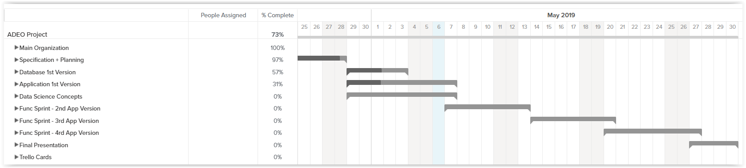

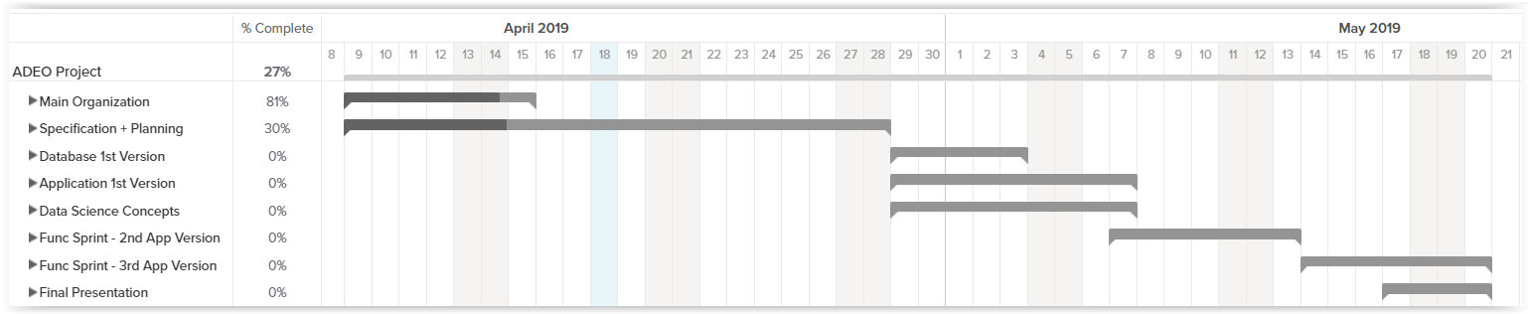

**Figure 1.** Gantt for all project

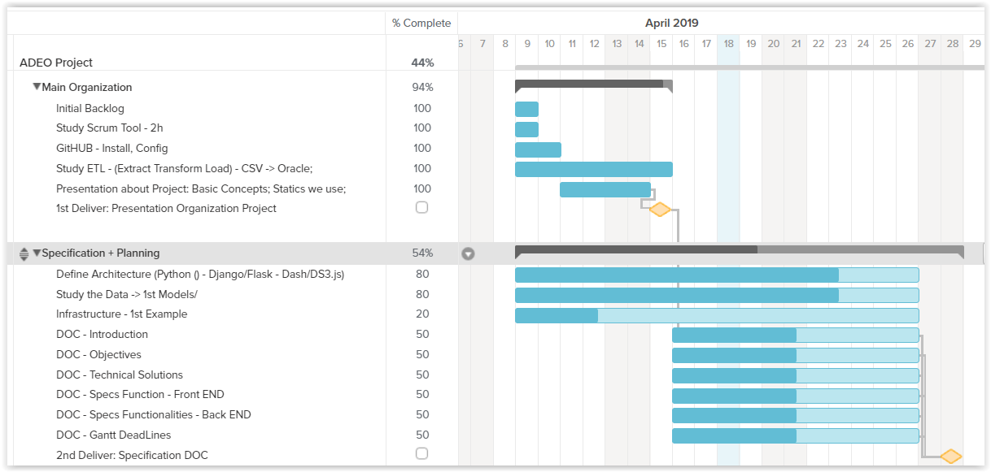

**Figure 2**. Tasks for Main Organization and Specification-Planning

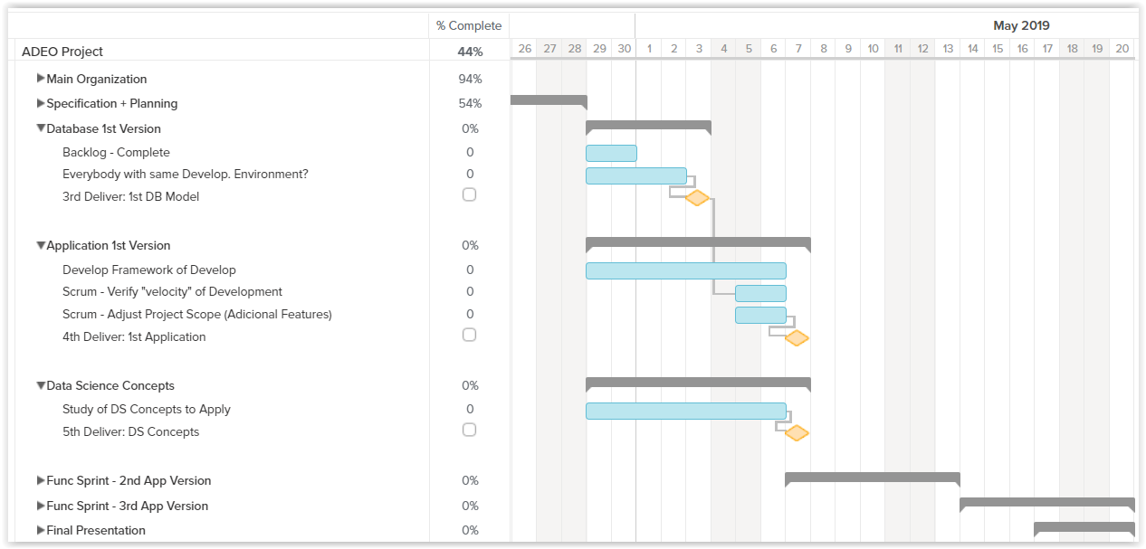

**Figure 3**. Tasks for “Database 1st Version”, “Application 1st Version”, “Data Science Concepts”, “Functional Sprints” and “Final Presentation”.